TO TEST OR NOT TEST: PRELIMINARY ASSESSMENT OF NORMALITY WHEN COMPARING TOW INDEPENDENT SAMPLES
Brief Overview of the Paper
Main Objective: The main objective of this paper is to evaluate the impact pf normality assumption on the results of two-sample t-test. It aimed at investigating whether the t-test is robust to moderate deviations from normality and whether alternative nonparametric test is needed when normality is violated.
The authors began by outlining the increasing importance of statistical test in several research fields of study particularly in the medical field where most clinical trials yield data where the objective is to compare whether two independent samples differ from each other or not. They however decry the numerous statistical errors usually reported in these journals arising from using test procedures that require normally distributed data on data that is skewed (Olse,2003). The student’s t test procedure which is the most common procedure used in most situations assumes that the samples are drawn from a normally distributed population with equal variance and so if the assumptions are violated, the test statistic is compared with the wrong reference distribution, which may result in deviation of the actual Type I Error from the nominal significance level, and loss of power. They emphasize the need to check distributional assumptions before performing the parametric t test procedure on data resulting from these types of research. They noted that data resulting from medical research are usually not normally distributed making the parametric test procedures less reliant. The nonparametric, Mann-Whitney U test is usually recommended when distributional assumptions are not satisfied. Vickers, in 2005 also suggested that such data are best analyzed with analysis of covariance. Conventional statistical practice for comparing continuous outcomes from independent samples is to use a pretest for normality before testing the main hypothesis. This procedure has, however, been criticized for its theoretical drawbacks. First, the mere fact that there is not enough evidence to reject the null hypothesis does not suggest that the data are normally distributed. Schucany and Ng, 2006 emphasized that preliminary testing focused on the fact assumptions refer to characteristics of the population and not characteristics of the samples. This problem is more pronounced when the sample size is small, according to. Schucany and Ng, 2006. The paper also criticized that some preliminary tests require their own assumptions raising the question as to whether these assumptions also need to be examined. It is again noted that if the pretest fails, the actual test may still be robust for some data and so preliminary tests are not that necessary. Some authors also stated that, the fact that preliminary tests are applied to the same data as the subsequent test can result in uncontrolled type I error rates. Rasch et al 2011 argued that assumptions underlying the two-sample t test should not be pretested as pretesting leads to unknown final Type I and Type II Error Rates if the respective statistical tests are performed using the same set of observations.
In the current paper, the authors investigated the statistical properties of the student’s t test and Mann-Whitney’s U test by comparing two independent groups with different selection procedures. A simulation study is conducted by drawing equal samples of sizes 20, 30, 40, and 50 for two independent groups from three different distributions, exponential, Uniform, and Normal distributions. Two selection strategies were examined. In one strategy, the two samples t test was conducted if both samples had passed the preliminary Shapiro-Wilk test for normality, otherwise the Mann-Whitney’s U test was used whereas in the other strategy, the t test was used if the residuals of the collapsed samples $(x_{i}-m_{x})$ and $(y-m_{y})$ had passed Shapiro-Wilk test for normality otherwise the Mann-Whitney’s U test was used.
In the first simulation the procedure was repeated until 10000 pairs of samples had passed the preliminary screening for normality by either strategy I or II with $α_{pre}=0.1, 0.05, 0.01,0.05$ or no pretest. The conditional Type I Error Rates were then estimated by the number of significant t tests divided by 10000. In the second simulation the procedure was repeated until 10000 pairs of samples had failed the preliminary screening for normality by either strategy I or II with $α_{pre}=0.1, 0.05, 0.01,0.05$ or no pretest. The conditional Type I Error Rates were then estimated by the number of significant t tests divided by 10000. Lastly, 100000 pairs of samples were generated to assess the unconditional Type I Error Rate of the entire procedure. Depending on whether the preliminary Shapiro Wilk test was significant or not, Student’s t test of Mann-Whitney U test was performed for the main analysis. The Type I error rate of the entire two-stage procedure was estimated by dividing the number of significant test (t or U) and divided by 100000.

Results and Analysis
Estimated Type I Errors of two sample t test after a passed Shapiro-Wilk test for normality.
The tables below contain the estimated type I error rate for the two-sample t test for samples drawn from uniform and normally distributed population at $α=0.05$ after both samples had passed Shapiro-Wilk test for normality. To the left are our simulations, and to the right are the estimates from the paper “To test or not to test.”
Estimates from Our simulation |  |  |  |  |  |  | Estimates from the paper
Uniform Distribution |  |  |  |  |  |  | Uniform Distribution
α_pre/n | 10 | 20 | 30 | 40 | 50 |  | α_pre/n | 10 | 20 | 30 | 40 | 50
0.1 | 0.042 | 0.044 | 0.039 | 0.035 | 0.036 |  | 0.1 | 0.043 | 0.044 | 0.039 | 0.039 | 0.036
0.05 | 0.044 | 0.044 | 0.042 | 0.038 | 0.037 |  | 0.05 | 0.043 | 0.037 | 0.04 | 0.04 | 0.037
0.01 | 0.049 | 0.046 | 0.046 | 0.044 | 0.044 |  | 0.01 | 0.049 | 0.05 | 0.046 | 0.045 | 0.041
0.005 | 0.052 | 0.049 | 0.047 | 0.045 | 0.045 |  | 0.005 | 0.052 | 0.05 | 0.048 | 0.044 | 0.043
w/o pretest | 0.053 | 0.048 | 0.051 | 0.052 | 0.049 |  | w/o pretest | 0.058 | 0.047 | 0.052 | 0.047 | 0.05
Normal Distribution |  |  |  |  |  |  | Normal Distribution
α_pre/n | 10 | 20 | 30 | 40 | 50 |  | α_pre/n | 10 | 20 | 30 | 40 | 50
0.1 | 0.05 | 0.053 | 0.05 | 0.048 | 0.05 |  | 0.1 | 0.049 | 0.053 | 0.05 | 0.049 | 0.05
0.05 | 0.044 | 0.049 | 0.047 | 0.05 | 0.047 |  | 0.05 | 0.049 | 0.05 | 0.05 | 0.053 | 0.046
0.01 | 0.05 | 0.049 | 0.054 | 0.049 | 0.048 |  | 0.01 | 0.05 | 0.05 | 0.047 | 0.048 | 0.051
0.005 | 0.046 | 0.051 | 0.046 | 0.053 | 0.05 |  | 0.005 | 0.047 | 0.047 | 0.05 | 0.054 | 0.05
w/o pretest | 0.048 | 0.051 | 0.047 | 0.049 | 0.05 |  | w/o pretest | 0.051 | 0.053 | 0.049 | 0.053 | 0.05

Conditional type I error rate decreases with sample sizes but increases with $α_{pre}$. For example, conditional Type Error rate decreases from 0.042 to 0.036 from sample sizes 10 to 50 but not in a consistent manner for uniform distribution. As $α_{pre}$ increases from 0.1 to 0.005, conditional type I error rate increases from 0.042 to 0.053 for exponential distribution.

Observations:
The two results are relatively the same with a few differences in decimal places. There are no results for exponential. It has unreasonable runtime after sample size 30. I verified that my code works with different sample sizes and the result is shown below. The plot of Type I error rate against various sample sizes are also shown below.

Exponential Distribution
α_pre/n | 5 | 10 | 15 | 20 | 25
0.1 | 0.033 | 0.075 | 0.119 | 0.142 | 0.155
0.05 | 0.033 | 0.067 | 0.096 | 0.118 | 0.135
0.01 | 0.03 | 0.05 | 0.073 | 0.092 | 0.105
0.005 | 0.029 | 0.049 | 0.065 | 0.079 | 0.1
w/o pretest | 0.026 | 0.036 | 0.04 | 0.044 | 0.046

Figures 1.1 and 1.2 below are the plot of Type I error rate against sample sizes for normal and uniform distribution.
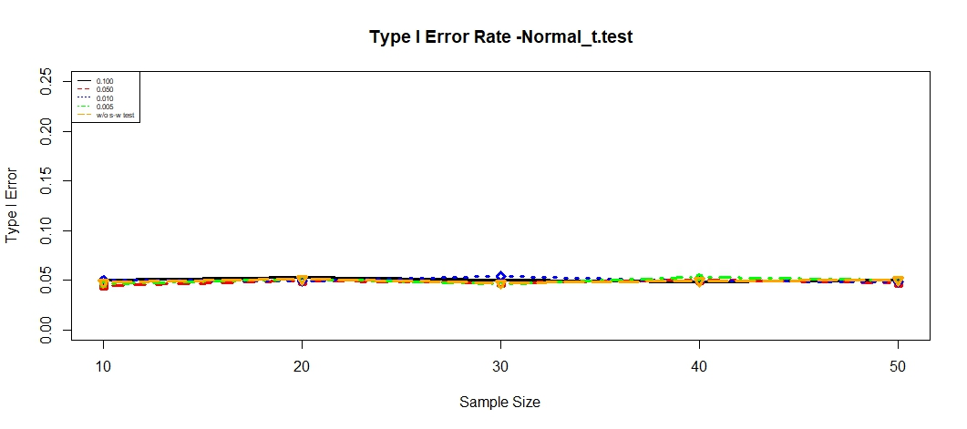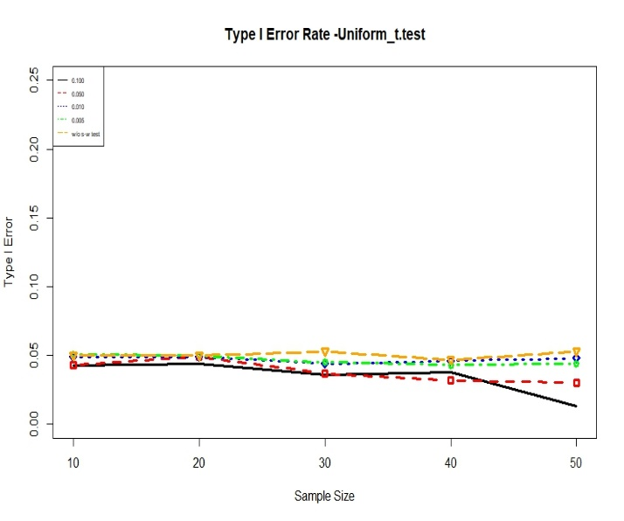
Figure 1.1 Figure 1.2

Estimated Type I Error probability of the two-stage procedure (Student’s t test or Mann-Whitney’s U test depending on preliminary Shapiro Wilk test for normality) for different sample sizes and $α_{pre}$

Estimates from Our simulation |  |  |  |  |  |  | Estimates from the paper
Exponential Distribution |  |  |  |  |  |  | Exponential Distribution
α_pre/n | 10 | 20 | 30 | 40 | 50 |  | α_pre/n | 10 | 20 | 30 | 40 | 50
0.1 | 0.050 | 0.052 | 0.049 | 0.050 | 0.049 |  | 0.1 | 0.053 | 0.050 | 0.048 | 0.049 | 0.048
0.05 | 0.050 | 0.051 | 0.05 | 0.050 | 0.050 |  | 0.05 | 0.055 | 0.052 | 0.048 | 0.049 | 0.050
0.01 | 0.051 | 0.052 | 0.049 | 0.050 | 0.049 |  | 0.01 | 0.054 | 0.054 | 0.048 | 0.049 | 0.050
0.005 | 0.051 | 0.051 | 0.051 | 0.051 | 0.050 |  | 0.005 | 0.050 | 0.055 | 0.049 | 0.048 | 0.049
Normal Distribution |  |  |  |  |  |  | Normal Distribution
α_pre/n | 10 | 20 | 30 | 40 | 50 |  | α_pre/n | 10 | 20 | 30 | 40 | 50
0.1 | 0.05 | 0.052 | 0.052 | 0.051 | 0.051 |  | 0.1 | 0.051 | 0.052 | 0.053 | 0.051 | 0.051
0.05 | 0.05 | 0.051 | 0.051 | 0.051 | 0.051 |  | 0.05 | 0.051 | 0.051 | 0.051 | 0.051 | 0.050
0.01 | 0.051 | 0.051 | 0.052 | 0.052 | 0.052 |  | 0.01 | 0.051 | 0.051 | 0.051 | 0.051 | 0.051
0.005 | 0.05 | 0.051 | 0.052 | 0.051 | 0.051 |  | 0.005 | 0.051 | 0.050 | 0.049 | 0.050 | 0.050
Uniform Distribution |  |  |  |  |  |  | Uniform Distribution
α_pre/n | 10 | 20 | 30 | 40 | 50 |  | α_pre/n | 10 | 20 | 30 | 40 | 50
0.1 | 0.052 | 0.050 | 0.051 | 0.049 | 0.049 |  | 0.1 | 0.052 | 0.051 | 0.048 | 0.049 | 0.049
0.05 | 0.051 | 0.052 | 0.051 | 0.05 | 0.051 |  | 0.05 | 0.053 | 0.051 | 0.051 | 0.050 | 0.048
0.01 | 0.051 | 0.052 | 0.051 | 0.050 | 0.050 |  | 0.01 | 0.051 | 0.051 | 0.052 | 0.051 | 0.051
0.005 | 0.052 | 0.052 | 0.051 | 0.051 | 0.048 |  | 0.005 | 0.052 | 0.050 | 0.050 | 0.052 | 0.050

